**Homework 3**

**Instructions:** Do as many of the problems as you like, but make sure to complete at least **three**.

1. Thinking like an instructor: Make up a solvable Diophantine equation. Explain what process you used and which results you relied on during the process.
2. Use Euclidean algorithm to find the gcd of the following pairs:   
   a. 123, 456   
   b. 1234, 567
3. What are the possible values of $gcd(8n^{2}+14n+6, 2n+3)=1$? If you guess a possible value, make sure that it occurs.
4. a. Find an integer solution to the equation $561x+379y=1$.  
   b. Find a second solution with *x>*0.
5. Show that [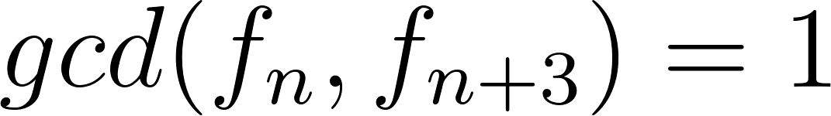](https://www.codecogs.com/eqnedit.php?latex=gcd(f_n%2C%20f_%7Bn%2B3%7D)%3D1#0) or 2.
6. Prove that if *c>*0, then [](https://www.codecogs.com/eqnedit.php?latex=lcm(ac%2Cbc)%3Dc%5Ccdot%20lcm(a%2Cb)#0).
7. Show that if [](https://www.codecogs.com/eqnedit.php?latex=gcd(a%2Cb)%3Dr%20%2C%20gcd(a%2Cc)%3Ds#0) and [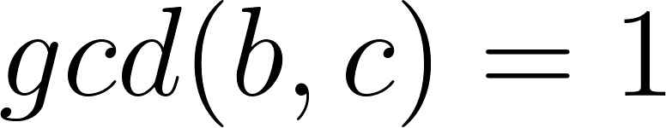](https://www.codecogs.com/eqnedit.php?latex=gcd(b%2Cc)%3D1#0), then [](https://www.codecogs.com/eqnedit.php?latex=gcd(a%2Cbc)%3Drs#0). Give an example to show that this need not be true if [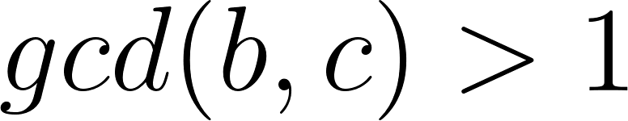](https://www.codecogs.com/eqnedit.php?latex=gcd(b%2Cc)%3E1#0).
8. Write a code to implement the Euclidean algorithm to find gcd.